Lab 3

Linux CBT (1-4)

By

Lukas Fuller

IAE-201-D02

Intro to Linux Training

**Abstract**

The objective of this lab is to introduce students to the Linux operating system. The student will be able to navigate a Linux system via command line and understand its file structure. The student will understand basic file permissions and how to utilize common Linux commands.

**Materials**

1. Kali Linux VM

**Conclusion**

This lab helped me understand how to use some of the basic functions in the Linux environment. I learned some of the basics from my UNIX class that I’m also taking at this moment, but some of the ones I didn’t know about were like chmod, echo, and cat. I think I messed up one or two of the steps, but for the most part I feel confident in my understanding of kali so far. Practice makes perfect I guess.

**Screenshots**

1. Root Directory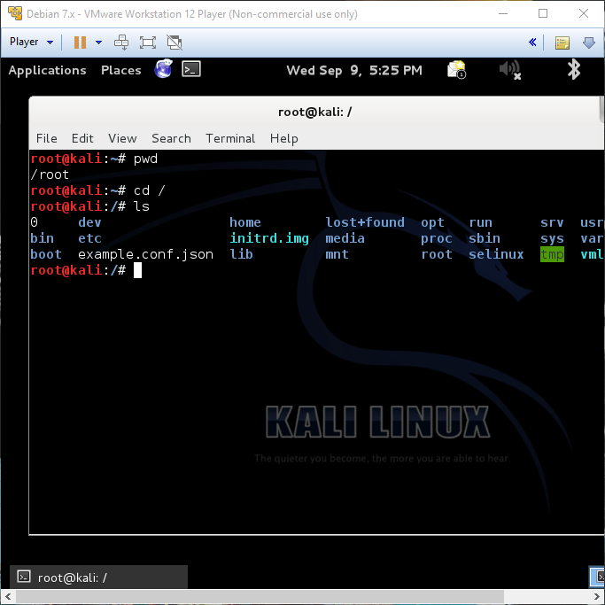

2. Man pages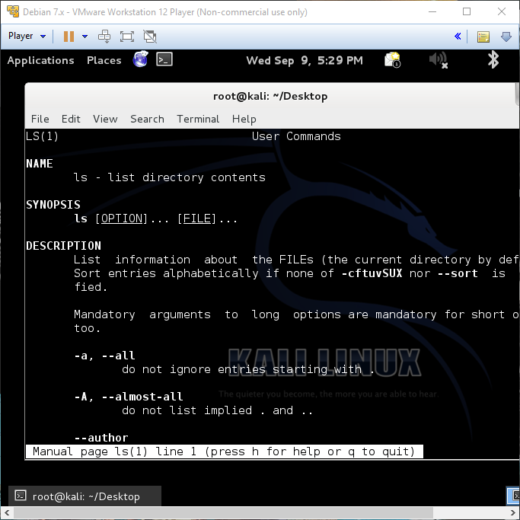

3. Home directory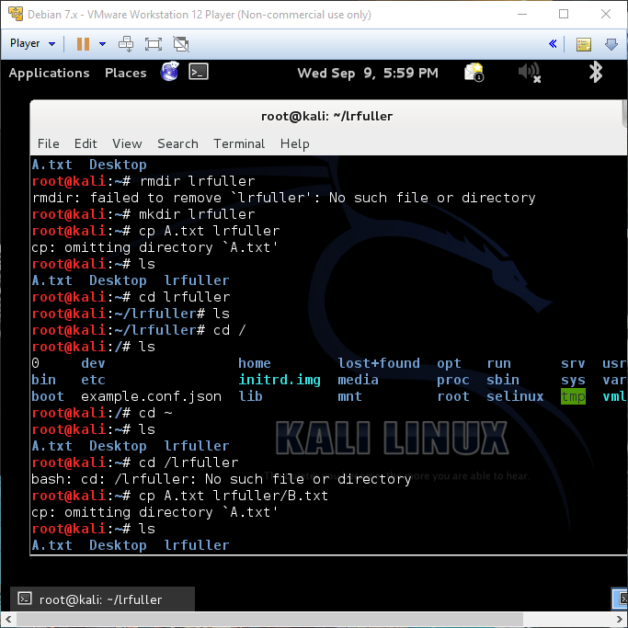

4. <YOUR-NAME-FOLDER> Home directory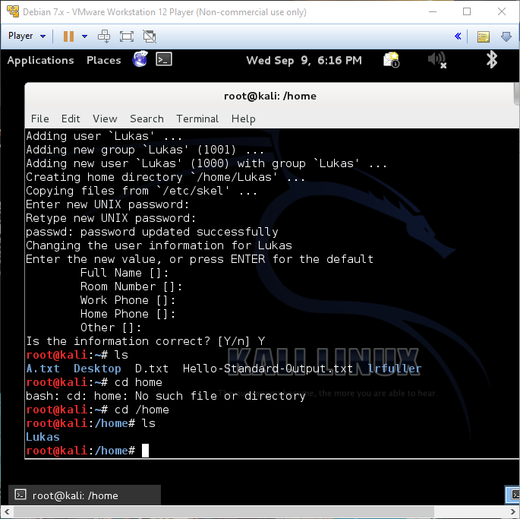

5. <YOUR-NAME-FOLDER> PNG files 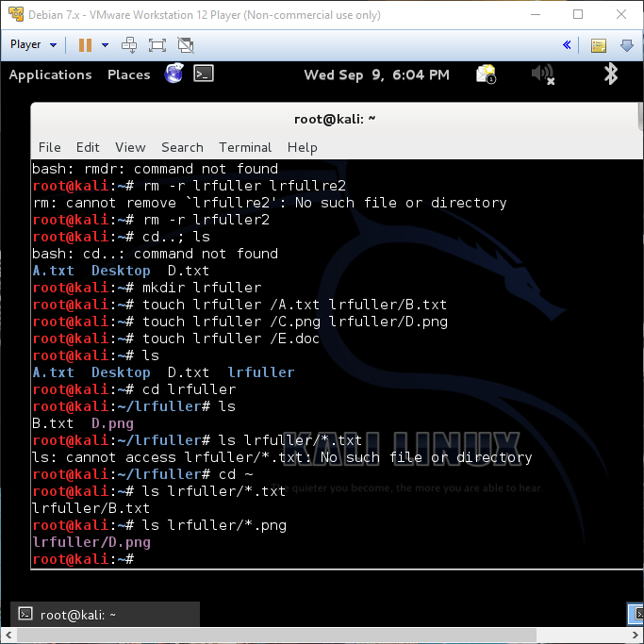

6. /home after a new user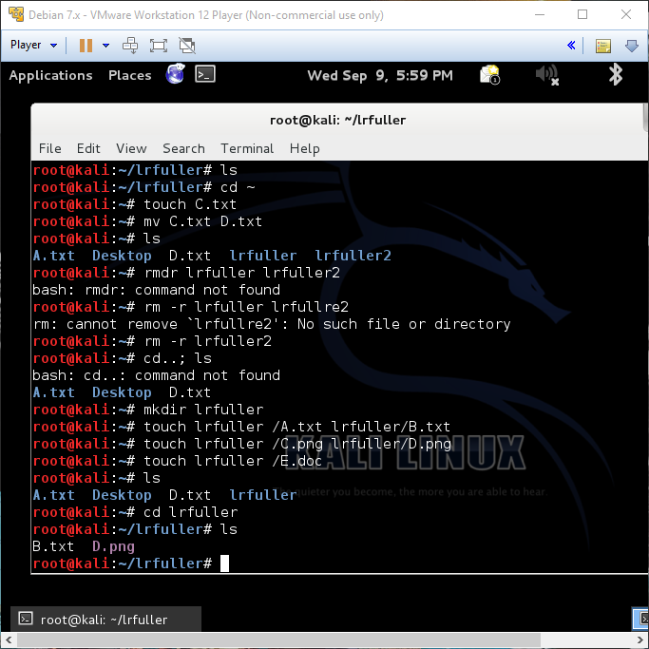

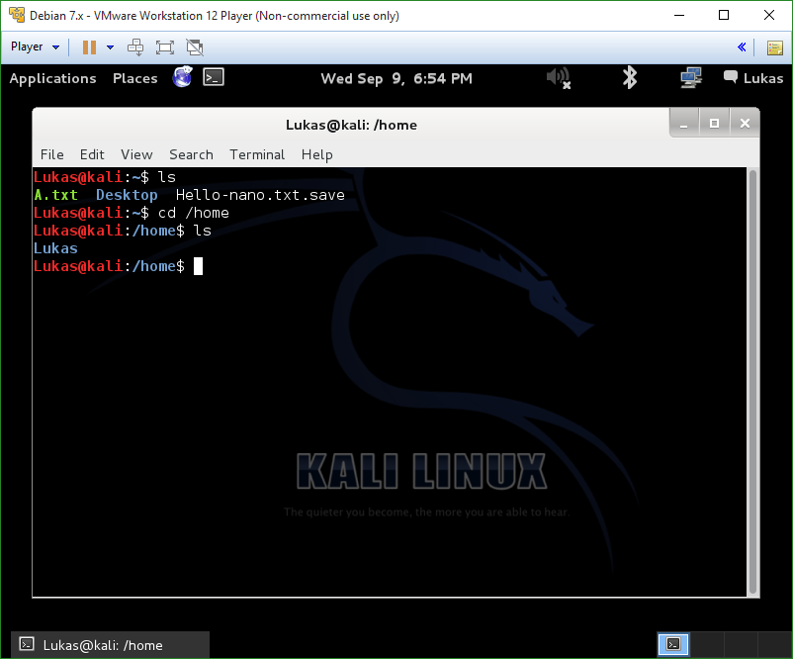

7. whoami, id printed on screen for new user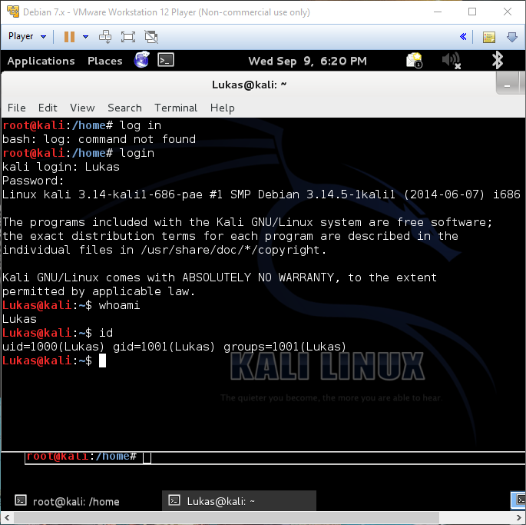

8. File permissions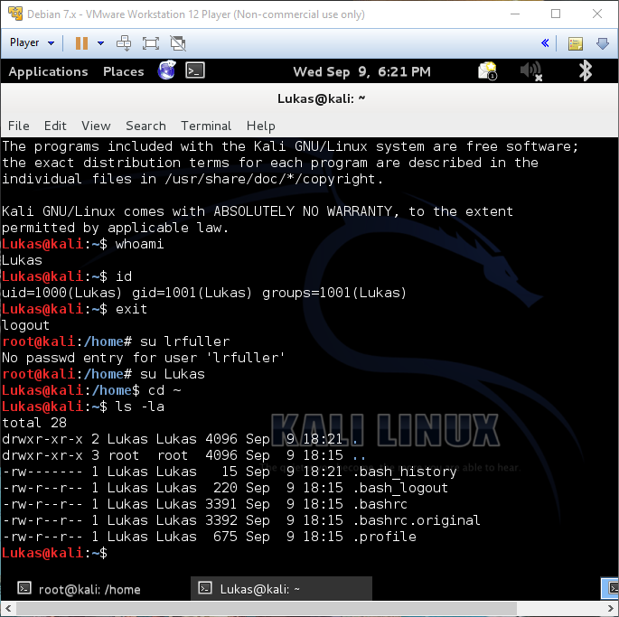

9. VI and Nano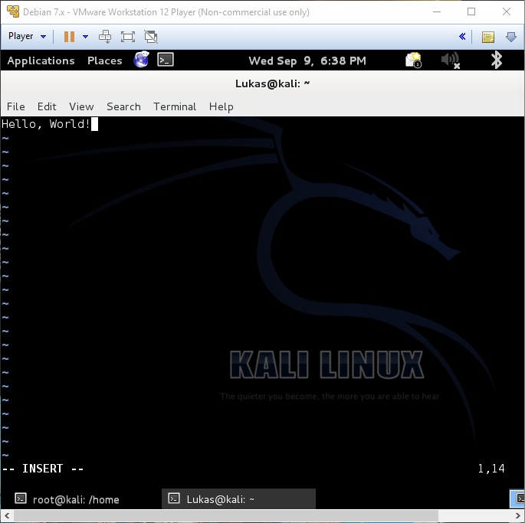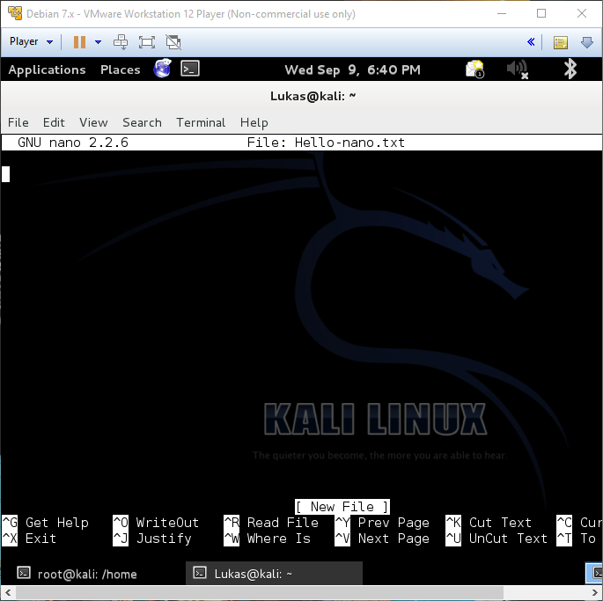

**Questions**

1. What is your working directory when you first log into the system as root? **/root**

2. What is the command to change directories? **cd**

3. What is the command to list files in a directory? **ls**

4. What command do you use to look up how to use a command? **man ls**

5. What is one command to print a file to the console? **cat**

6. What is the command to delete a file? **rm**

7. What is the command to delete a folder? **rmdir**

8. What is the command to copy a file? **cp**

9. What is the command to copy a folder? **cp -r**

10. What is the command to move a file or folder? **mv**

11. What is the command to save the output of a command and what is it called? **echo**

12. What is the command to use a file as input for a command and what is it called? **<**

13. What is the command to use the output of a file and direct it for use in another command? **>>**

14. What is the command to change a password? **psw**

15. What is the command to change file permissions? **chmod**

16. What does the file permissions (the portion shown above) read for “A.txt” when you first create it? (In the form of: - --- --- ---) **drwxr-xr-x 2**

17. Give the owner read, write, and execute permissions; give the group read permissions; and give all others no permissions for “A.txt”. What does the file permissions read when you list the file? (In the form of: - --- --- ---) **-rw-r--r--**

18. What is one command you can use to edit files? **nano**